Antonio Urdaneta

2/2/2023

Android Application Instructions

This is a user-friendly application that will help you calculate the currency exchange for three different currencies: Chinese Yen, American Dollar, and Canadian Dollar. (The App does not support steps 1-4)

1.- Download the app "Your Exchange Calculator" from the android or Ios store.

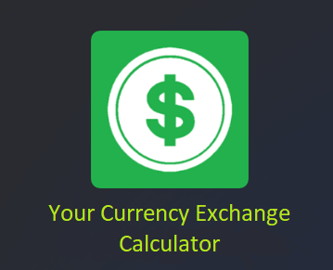

2.- Input your credentials to validate your app purchase.

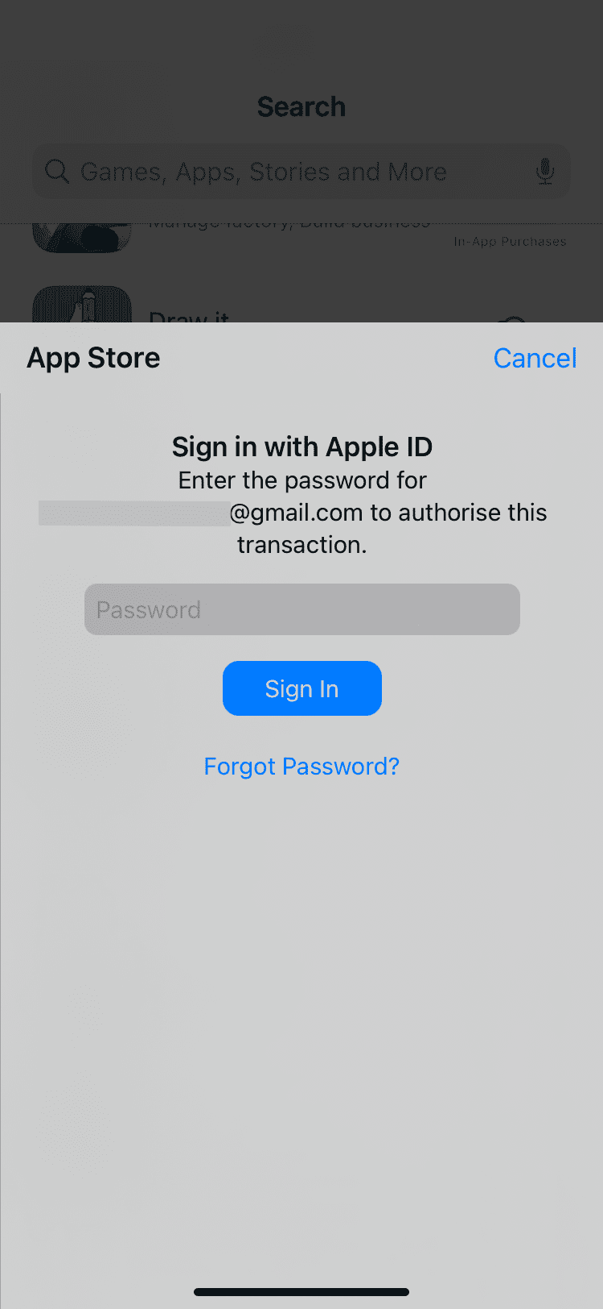

3.- Wait for the app to download and then open it.

4.- Once you are in the app, it will ask you to "Sign up" or "Log in" if you already have an account with us.

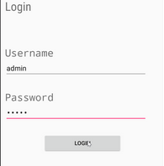

5.- After you log in to the app, you will find four different buttons (YEN, CAN, US) for the currencies and (NEXT) to continue. On this page, you will choose the currency you will be exchanging for the calculation.

6.- Select one of the currencies and then press the button next.

7.- Now, you will encounter two text fields, one showing the currency you selected and another empty; both with a button to the right.

8.- Write the amount of money you would like to exchange on the text field above of your chosen currency.

9.- Go to the text field below, select the new currency you would like to exchange for, and press TO USD.

10.- Now, the exchange amount will appear on the new currency Text field, and the calculation is done!

Tips:

-You can recalculate the currency by inserting different sums.

-You can select the second currency and exchange based on the primary you selected on the first selection.

- If you need to change your first selection, there will be a (BACK) button that will take you to the main page again so you can reselect a new currency for exchange.

References:

Razormist. “Simple Login Application.” *Sourcecodester*, 12 Jan. 2021, https://www.sourcecodester.com/android/11968/android-simple-login-application-beginners.html.